
Genealogy Study of Artists No. 21
Jiang Quyang: Emanation
Date: August 13th- September 27th, 2026
Address: START Museum (S Space)
Ruining Road No.111, Xuhui District, Shanghai

Jiang Quyang: From Image to Essence

START Museum will present Chinese young artist Jiang Quyang’s solo exhibition Emanation on August 13th, 2026. This exhibition marks the 21st case study of the museum’s ongoing “Genealogy Study of Artists” project, and is also Jiang Quyang’s first museum solo exhibition.

The “Genealogy Study of Artists” project is an ongoing research initiative carried out by START Museum since 2018. This innovative project establishes a continuous academic research platform focused on the interplay between an artist’s personal genealogy and artistic creation, utilizing exhibitions, publications, sound documentation, visual materials, and historical literature to systematically explore the artistic evolution of the featured artists.

Jiang Quyang (b. 1985) graduated from the Mural Painting Department of China Academy of Art in 2008 and has continuously pursued artistic exploration through oil painting as his primary medium. By extremely magnifying specific parts of living organisms, he creates new visual spectacles and cognitive displacements, challenging established narrative experiences through a “microscopic” perspective. However, his restrained use of color and classical compositional structures introduce a layer of emotional and timeless luminosity into his works. This contradictory quality distinguishes Jiang among emerging painters and makes him a unique case within contemporary young artistic practices.

In Emanation, Jiang Quyang presents 15 new works created between 2025 and 2026 with an exceptionally refined and detailed visual language. Among them, Mantou Mountain (2026, 150 × 400 cm) is one of the artist’s rare large-scale works. Using the proportions of traditional Chinese handscrolls, Jiang presents a magnified fragment of a cactus in a sculptural, fleshy form with the imposing presence of a mountain landscape. Against the dark red background, the more microscopic it becomes, the more immense it appears; the more realistic it becomes, the more unreal it feels.

This intense cognitive contradiction is further amplified in Celestial Body (2026, 100 × 100 cm). The Mars-like imagery and luminous color halos in the work resemble all of our contemporary associations with the universe and stars—hazy and illusory—so much so that one cannot believe that it depicts a tiny, ordinary plant seed.

In several small-scale works, Jiang Quyang employs his self-developed technique of layering thick pigments to transform the texture of oil painting into a more materialized visual experience. Through observation, viewers can almost imagine the tactile qualities of the depicted objects—their elasticity, dampness, and softness. The artist attempts to immerse viewers within the process of looking through a series of “playful provocations,” including the manipulation of scale, the subtle deception of light and shadow, and the ambiguity of synesthetic perception. The more realistically Jiang paints, the more difficult it becomes for viewers to believe in the reality of what they see—because viewers have unconsciously moved from the surface of image and enters the deeper realm of essence carefully constructed by the artist. This inevitably raises a fundamental question: Is the image that I perceive truly the essence that I know? Which represents reality, and which belongs to consciousness?

The exhibition will be on view at START Museum’s S Space on the second floor until September 27th, 2026.

“‘Emanation’ is a way that I choose to approach the image… Every plant and every person is the same. I look at each object through the method of ‘portraiture.’”
—Jiang Quyang

Contact us：media@startmuseum.com
ARTIST PROFILE

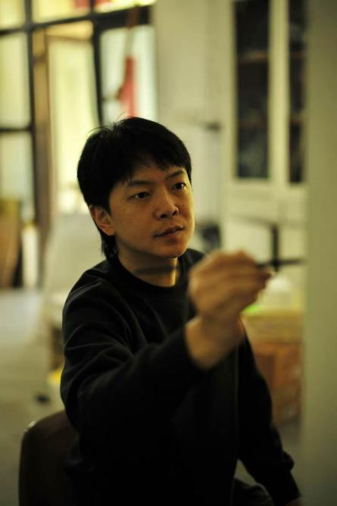
Courtesy of the artist
Jiang Quyang

Jiang Quyang, born 1985 in Quzhou, Zhejiang Province, China. Lives and works in Hangzhou, China.

Solo Exhibition: "Emanation" , START Museum, Shanghai, 2026; "Seeming is the being" , Collector's Mansion, Shanghai, 2025; "Botanical Inner Map", B1OCK Gallery, Hangzhou, 2025; "Partial Scenery", BLANKgallery, Shanghai, 2024; "Brushing Shadows", BLANKgallery, Shanghai, 2022;

Group Exhibition: "The Collection of Flowers and Birds 10", Hangzhou, 2025; "MICROCOSM: Intimacies Beyond Distance", Tang Contemporary Art, Singapore, 2025; "RGB", RIVERSIDE, Hangzhou, 2025; "The Preparation of Art", Quzhou City Culture and Art Museum, Quzhou, 2025; "RADIUS OF MOONLIGHT", Ray Gallery, Shanghai, 2025; "Meme to jam, X sign Space & BRITA 131", Hangzhou, 2024; "The Collection of Flowers and Birds 9", Hangzhou, 2024; "Equal Value", RIVERSIDE, Hangzhou, 2024; "Primordial Dream", BLANK Gallery, Totyo, 2024; "The Collection of Flowers and Birds 8", Hangzhou, 2023; "Attend on Time", ARR Gallery, Hangzhou, 2023; "lín láng mǎn mù", INNA ART SPACE, Hangzhou, 2023; "The Collection of Flowers and Birds 7", Hangzhou, 2022; "Spring Blooming", BLANK Gallery, Shanghai, 2022.

