
START Museum Experimental Project
「Zero Degree of Image」 Vol. 1: Wu Di
Date: August 13th- September 27th, 2026
Address: START Museum (A Hall)
Ruining Road No.111, Xuhui District, Shanghai
START Museum will present the first artist case study of museum’s long-term experimental project "Zero Degree of Image", featuring arrtist Wu Di. The exhibition will be on view at A Hall on the first floor of START Museum from August 13 through September 27, 2026.

This exhibition marks artist Wu Di’s first large-scale museum exhibition to date. As the first artist case study of the “Zero Degree of Image” project, Wu Di has, throughout her more than two decades of artistic practice and exploration, consistently used her works as experimental samples, seeking more contemporary and powerful artistic expressions within the transmission of images, the materialization of language, and the power relations of color. She freely navigates through images from the entire history of both Chinese and Western art, social news, and cultural communication, extracting the visual elements that she perceives as constituting symbolic power. (Here, her individual perception and understanding transcend the power judgments imposed by so-called art history and social reality.)

By removing their original cultural and historical contexts and resetting visual perception through pure image structures and color relationships, she attempts to establish a new sense of sacredness and power within images. Yet this “sacredness” and “power” are simultaneously provocative, illusory, and fleeting. They are torn apart by delicate brushstrokes, consumed by repeatedly layered colors, and dissolved by the intentionally preserved rough textures of the artist’s surfaces. Thus, Wu Di once again completes a deconstruction of another dimension of her own images.

Wu Di’s art is also characterized by an extremely chaotic and free approach to form. She never confines herself to any single medium or mode of expression; oil painting, sketches, collage, sculpture, installation, sound, and even light and shadow can all become methods through which she captures and constructs images. In this exhibition, she paints monumental oil paintings with the lightness of sketches, compelling viewers to pay attention to their delicate brushwork and tactile qualities. She collages classical art historical images onto wood panels, reconstructing compositions and backgrounds, allowing the classics to remain suspended within modern reproduction technologies while radiating a “sacred aura.” She also pioneeringly employs large areas of highly saturated colors, challenging the “symbolic violence of color” within consumer culture rather than following the logic of abstraction…
This time, as an artist, Wu Di consciously and forcefully confronts contemporary systems of power, the sacredness of art, and the logic of contemporary communication. Through this practice, she presents the powerful and fearless life attitude and intellectual depth of a female artist.
Contact us：media@startmuseum.com

ARTIST PROFILE
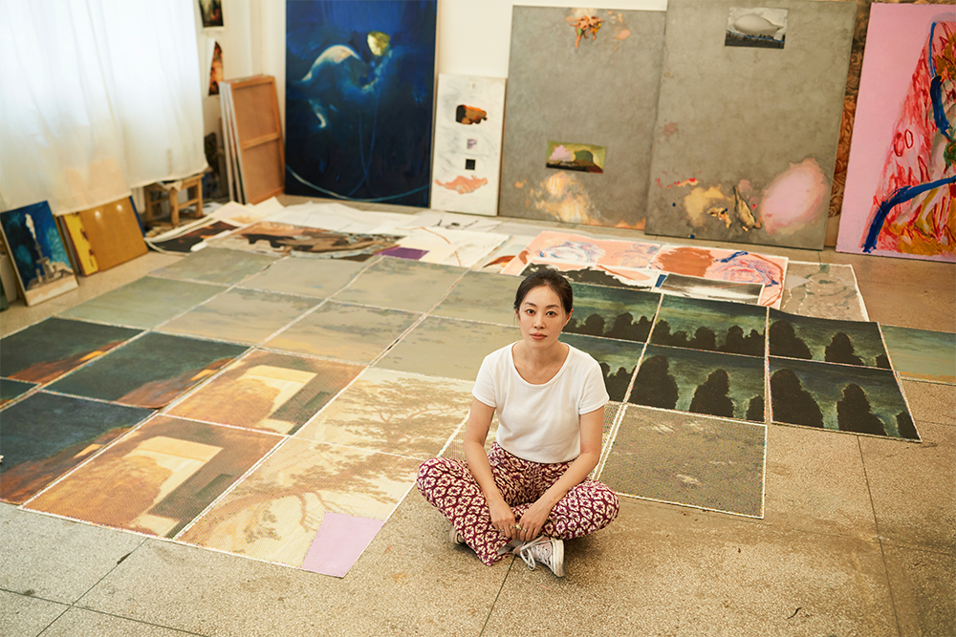
Courtesy of artist
Wu Di
Wu Di, born 1979 in Beijing, China. Lives and works in Beijing, China.

Solo Exhibition: “START Museum Experimental Project-Zero Degree of Image Vol. 1: Wu Di”, START MUSEUM, Shanghai, China, 2026; “On paper”, Star Gallery, Beijing, China, 2024; “Displacement”, 166 Art Space, Shanghai, China, 2021; “Little Sweet Loop”, CLC Gallery Venture, Beijing, China, 2020; “Symmetry”, 166 Art Space, Shanghai, China, 2019; “Wu Di, OMEN, OCAT”, Xi an, China, 2019; “Romantic Language”, SSSSTART, Shanghai, China, 2019; “Nine, C-Space+Local”, Beijing, China, 2017; “From Subway to Seaside”, Space Local, Beijing, China, 2015; “BABY, DON'T CRY”, PIFO Gallery, Beijing, China, 2013; “AMEISE, AMEISE”, PIFO Gallery, Beijing, China, 2009.

Group Exhibition: “Tangle of Revolution and Political Soul”, Shanghai Gallery of Art, Shanghai, China, 2021; “A Composite Leviathan”, Bridge Projects, Los Angeles, U.S, 2020; “A Composite Leviathan”, Luhring Augustine, New York, U.S, 2019; "The Wind in The Willows", C-Space+Local, Beijing, China, 2018; "Turning a Deaf Ear", C-Space+Local, Beijing, China, 2017; Collage, the poker player, Shanghai Gallery, Shanghai, China, 2017; “The third CAFAM Biennial”, CAFA Museum, Beijing, China 1 Apartment for 2 Woman 4 Men, Space Local, Beijing, China, 2016; “OVERPOP”, YUZ Museum, Shanghai, China, 2016; “Her”, International Female Artist Exhibition, Long Museum, Shanghai, China, 2016; “Space Local Opening Show”, Space Local, Beijing, China, 2015; “It is Said that Everything was lovely”, Shanghai Gallery, Shanghai, China, 2015; “SOVRAPPOSIZIONI DI IMMAGINI”, Casa dei Carraresi Museum, Italy Dawn - New Art from China, Zhong Gallery, Beijing, China, 2015; “Tomorrow's Party”, Ullens Center for Contemporary Art, Beijing, China, 2014; “Present-ing Recital Louder than Paint”, Shanghai Gallery of Art, Shanghai, China, 2014; “Some Like It Hot”, Shanghai Gallery of Art, Shanghai, China, 2013; “Daily of Concept: A Practice of Life - - The Fifth Shanghai Duolun Youth Art Exhibition”, Duolun Art, Museum, Shanghai, China, 2012; :Let's one -- artist + star the 3rd Portrait Exhibition”, Mingsheng Art Museum, Shanghai, China, 2012; “Dawn - New Art from China”, Zhong Gallery, Berlin, Germany, 2012; “Super-Organism CAFAM Biennale”, CAFA, Beijing, China, 2011; “Aspects of the Other - Italy in the Eyes of Chinese Artists”, Italy-China Touring Exhibition, 2011; “Fat Art 2010, Sanlitun Village, Beijing, China, 2010; “Thirty Years of Chinese Contemporary Art”, Minsheng Art Museum, Shanghai, China, 2010; “Constellations - Beijing 798 Biennale”, 706 Art Space, Beijing, China, 2009; “Future Sky Chinese Contemporary Young Artists Nomination Exhibition”, Today Art Museum, Beijing, China, 2008; “The Third A+A, Shanghai Duolun Museum of Modern Art”, Shanghai, China, 2008; “Jin Contemporary Art Exhibition”, Capital Normal University of Fine Arts, Beijing, China, 2007; “The Second A+A”, Gallery of Central Academy of Fine Arts / Sichuan University Art Museum / Chongqing Art Museum, Beijing / Si Chuang / Chong Qing / China, 2007; “Greater than Beijing, Today Art Museum”, Beijing, China, 2006; “From Beijing”, Rebin Academy of Fine Arts, Russia.
Public Collection: CAFA Museum, Yuz Museum, Minsheng Museum, Long Museum, START Museum.

